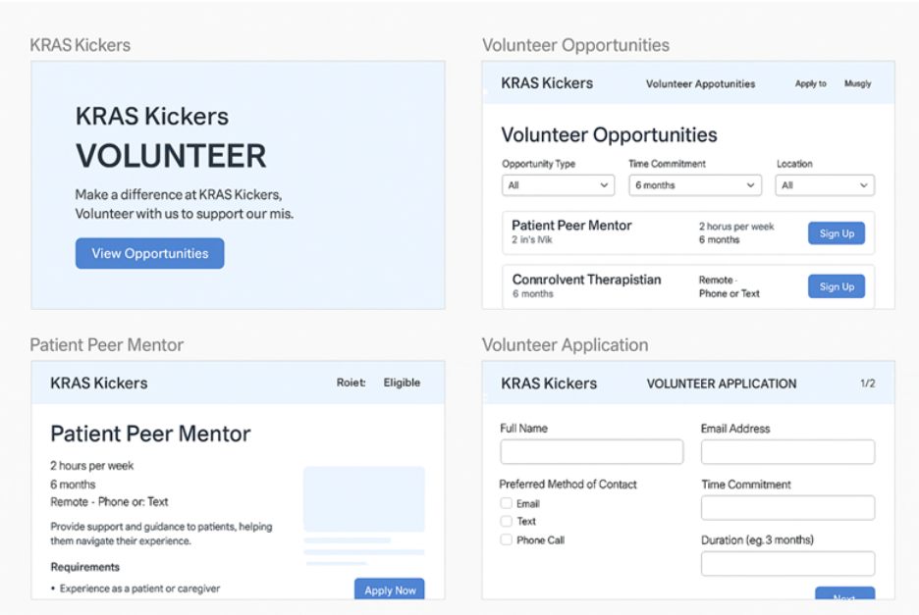
Here’s a clean, copy-and-follow plan to get your existing Flask app live on the web and embedded in Wix. This uses Render (free tier), then an Embed a Site block in Wix. Nothing in your Wix plan needs server code; the Flask server runs on Render.

1) Prepare your project locally
Your folder should look like this:
volunteer-app/
├── app.py
├── opportunities.json
├── requirements.txt ← you’ll add this
├── Procfile ← optional, but handy
├── static/
│ └── ...images...
└── templates/
├── index.html
└── manage.html
A. Create requirements.txt (exact content)
Flask==3.0.0
Werkzeug==3.0.1
gunicorn==21.2.0
You don’t need waitress on Render; gunicorn is the standard process manager.
B. (Optional but nice) Add Procfile
Render can use a Start Command, but a Procfile makes it portable:
web: gunicorn app:app
C. Ensure your app.py runs under gunicorn
You already have:
if __name__ == "__main__":
app.run(debug=True)
No change needed. Gunicorn will import app:app and ignore the __main__ block.
⚠️ Note on persistence: your code writes to opportunities.json and keeps APPLICATIONS in memory. On Render’s free dynos, data in memory and files may reset on redeploys or restarts. For demos it’s fine. For “real” persistence later, plan to move to SQLite/Postgres.

2) Push code to GitHub
From the project folder:
git init
git add .
git commit -m "Deployable Flask app for KRAS Kickers"
git branch -M main
# create a new empty repo on GitHub, then replace the URL below
git remote add origin https://github.com/<your-username>/kras-volunteer-app.git
git push -u origin main

3) Deploy on Render (free)
- Go to https://render.com → Sign up (GitHub).
- New + → Web Service.
- Pick your GitHub repo.
- Settings:
  - Name: kras-volunteer
  - Region: closest to you
  - Runtime: Auto (Python)
  - Build Command:
pip install -r requirements.txt
  - Start Command:
gunicorn app:app
- Click Create Web Service and let it build/deploy.
When it’s live you’ll get a URL like:
https://kras-volunteer.onrender.com
Open it to confirm your site works.
Tip: if you see a 502 while it “warms up,” give Render ~30–60 seconds after deploy.

4) Embed in Wix
- Open your Wix site → Editor.
- Add → Embed → Embed a Site (or “Embed widget”).
- Paste your Render URL (e.g., https://kras-volunteer.onrender.com).
- Set Width to 100% and Height to ~1600 px to start.
- Publish.
That’s it—your Flask site now shows inside your Wix page.

Optional niceties
Auto-height (no scrollbars) with Velo
If you want the embedded frame to auto-resize as the content grows, turn on Dev Mode (Velo) and add something like:
// Page Code in Wix
$w.onReady(function () {
// Select your embed element (e.g., #html1) and talk to it via postMessage if your Flask page sends height
});
On your Flask page, you’d post the document height to the parent. This is optional; many sites just set a tall iframe height and move on.
Custom domain
- In Render: Settings → Custom Domains (e.g., volunteer.kraskickers.org)
- In DNS: add CNAME per Render’s instructions
- In Wix: link your page’s navigation to the embedded section and you’re done
Persistence plan (later)
Right now:
- APPLICATIONS resets on server restart
- opportunities.json changes may be lost on redeploys
Easy next step:
- Switch to SQLite (file) or Render PostgreSQL (free tier) and swap your read/write helpers. Your UI and routes stay the same.

Quick troubleshooting
- White screen / 502 after deploy → wait a minute; then check Logs in Render. Common miss: wrong Start Command (should be gunicorn app:app).
- Static images not loading → ensure app = Flask(__name__, static_folder="static", static_url_path="/static") (you already have this).
- CORS → not needed for an iframe embed. Only needed if Wix pages call your Flask APIs directly via fetch().

Recap
- Add requirements.txt + (optional) Procfile
- Push to GitHub
- Create a Render Web Service → build with pip install -r requirements.txt, start with gunicorn app:app
- Embed the Render URL in Wix’s Embed a Site block
- Publish
When you’re ready, ask for a persistence upgrade plan and I’ll give you a drop-in SQLite version that keeps your JSON shape but survives restarts.

